Jonathan Quang 5/11/15

1WW

Approximations in Calculus

Legend says that basic calculus was discovered in a day by Sir Isaac Newton. While this legend is obviously untrue, the legend illustrates the simplicity of “discovering” calculus with basic integers.

Originally, the very beginning of calculus was finding the slope of a curve at a specific point. This proves a challenge as two points are used to determine a line. Finding the slope given an x-coordinate and a function is what this question boils down to. To solve this, two points on the curve should be selected. As the first point, called point A, has a point B move closer to point A on a graphed function, the slope of the two points seems to converge on a number. The point where the two points become just point A will determine the slope of a single point. Consider the most basic curve on a Cartesian plane, y=x2. Now imagine point A is at (3,9) on the line. For point B, select (6,36). The slope between A and B is now 9. For point B, select point (5,25) on the parabola. Now the slope between these two points would be 8. If point B was at (4,16), the slope would be 7. The slope only decreases by 1 as the x coordinate decreases by 1 on the parabola. However, no integer exists between a 3 and 4, so one might start approximating with decimals. Setting point B as (3.5, 12.25) , the slope is now 6.5. If point B is (3.01, 9.0601). the slope is 6.01. Someone could assume that the slope is 6. He or she would not be wrong. The slope of any point on y=x2 is actually twice the value of x.

Actually proving that the slope of a coordinate on y=x2 is similar to the process above, just with algebra. The slope of point A and B of these points is generally represented by the slope formula $\frac{∆y}{∆x}$ or the change in y over the change in x. Give point A the coordinates (x,y), then coordinates of point B must be (x+ $∆x$, y + $∆y$). Since y= x2, it can also be said that the y coordinate of point A is (x, x2) and (x+ , (x+2). Substitute these values into the slope formula, and the result is $\frac{{\left(x+∆x\right)}^{2} -x^{2}}{∆x}$. Expanding the numerator results in $\frac{x^{2}+2x∆x+ x∆^{2}-x^{2}}{∆x}$, which simplifies to $\frac{2x∆x+ x∆^{2}}{∆x}$, and then simplifies further into the slope being $2x+ x∆$. As with the problem in the paragraph above, the slope of a single point means that there is no change in the x coordinate. If x $∆$ = 0, then the slope of a point is simply 2x + 0, or just 2x.

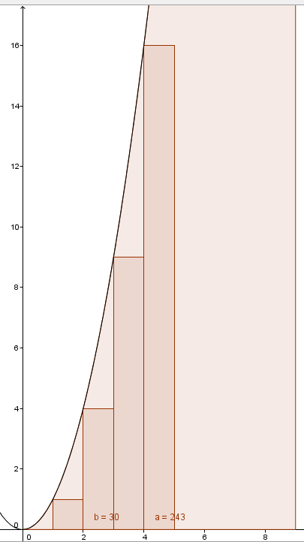 While, Newton started with the problem of derivatives, Gottfried Wilhelm Leibniz was independently working on the concept of integrals. The basic problem of integrals is the area of the space under a curved function, generally sticking to the first quadrant of the Cartesian plane. Approximating the area under y=x2 can be done with rectangles with a width of 1. The first rectangle has a width of 1, and a height of 1. The second rectangle is at an x coordinate of 2, and thus has a width of 1 but a height of 22=4. For the third rectangle at an x coordinate, the height is 32=9. The height of a rectangle multiplied by its width would mean that the area of each rectangle is its x-coordinate squared. As a result, the approximate area under the curve can be found as consecutive sum of squares. The sum of squares can be represented by or 12+22+32+42+52...

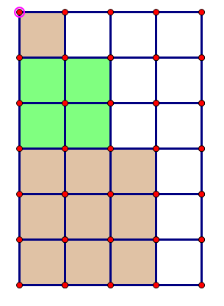Finding the sum of squares requires understanding that the sum of a sequence of integers starting from 1 to n is $\frac{n(n+1)}{2}$. Finding a formula for the sum of squares is slightly more complicated than this. Generally, using three dimensional graphics to derive the sum of squares is   
  
  
  
  
used, but there is a much simpler way.

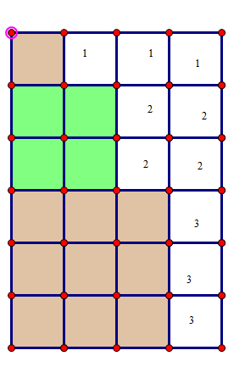If one draws squares with the next square placed under it with a side length equal to the term length in the sequence, the colored squares in the picture above are created. If a rectangle is created where the width is one more than the side length of the largest square and with a length equal to the combined lengths of all squares, then the rectangle's area can be represented as (n+1)(the sum of all positive integers to the nth term). Since the sum of all positive integers up to the nth term is $\frac{n(n+1)}{2}$, the area of the rectangle is (n+1) $(\frac{n(n+1)}{2})$. Logically speaking, subtracting the amount of uncolored squares from the area of the rectangle should yield the sum of squares, meaning $\sum_{n=1}^{∞}{n^{2}}$ = the uncolored area subtracted from (n+1) $(\frac{n(n+1)}{2})$. In the picture on the right, the uncolored area is composed of sum of positive integers. One could say that the uncolored area is (1+2+3)+(1+2)+1 and the area of the rectangle is (3+1)(1+2+3). This makes the sum of squares up to the third term. (3+1)(1+2+3) - (1+2+3)+(1+2)+1, which equals 14. This way of calculating the sum of squares is certainly helpful since the sum of positive integers can be substituted in. The problem here is using the sum of positive integers to express the area of the uncolored area. The uncolored area is the sum of the sum of positive integers to the first term + the sum of positive integers to the second term all the way to the sum of positive integers of the nth term. This can be represented as $\sum_{i=1}^{n}{(\sum_{j=1}^{n}{i})}$. Overall, the sum of squares can be represented by $\sum_{n=1}^{n}{n^{2}}$ =(n+1) $(\frac{n(n+1)}{2})$- $\sum_{i=1}^{n}{(\sum_{i=1}^{n}{i})}$.

If we substitute into the righter most sigma notation the formula for the sum of positive integers, then the equation is now $\sum_{n=1}^{n}{n^{2}}$ =(n+1) $(\frac{n(n+1)}{2})$- $\sum_{i=1}^{n}{(\frac{i(i+1)}{2})}$. Say we multiply both sides of the equation by 2 to get rid of the fractions, the result is $2(\sum_{n=1}^{∞}{n^{2})}$ =(n+1) $(n(n+1))$- $\sum_{i=1}^{n}{(i(i+1)}$). Now, here is the creative part. If we multiply out the last two terms, the result is $2(\sum_{n=1}^{∞}{n^{2})}$ =(n+1) $(n(n+1))$- $\sum_{i=1}^{n}{(i^{2}}+i$). $\sum_{i=1}^{n}{(i^{2}}+i$) is another way of saying that the sum of consecutive positive integers squared plus the sum of consecutive positive integers. If we substitute in the summation notation for the sum of squares and the sum of consecutive positive integers formula, the result is $2(\sum_{n=1}^{∞}{n^{2})}$ =(n+1) $(n(n+1))$- $\sum_{n=1}^{∞}{n^{2}}$- $\frac{n(n+1)}{2}$. If we add $\sum_{n=1}^{∞}{n^{2}}$ to both sides, the result is $3(\sum_{n=1}^{∞}{n^{2})}$ =(n+1) $(n(n+1))$- $\frac{n(n+1)}{2}$. Now we multiply out the right sides of the equation to get = n3+2n2+n - . This all boils down to =n3 + . Dividing both sides by 3 yields the sum of consecutive positive squares, $(\sum_{n=1}^{∞}{n^{2})}=\frac{n^{3}}{3}+\frac{n^{2}}{2} + \frac{n}{6}$. This simplifies to the more popular format of $\sum_{n=1}^{∞}{n^{2}}=\frac{{2n}^{3}+3n^{2}+n}{6}$.

This is nice and all, but this only concerns the parabola y = x2. Integrals are used to find the area under any curve of a function.

http://tutorial.math.lamar.edu/Classes/CalcII/ApproximatingDefIntegrals.aspx